Model Context Protocol

# Last amended: 21st Sep, 2026
# Myfolder:
# GitHub link is here

How does MCP help?

The Model Context Protocol (MCP) is an open standard and open-source framework introduced by Anthropic in November 2024 to standardize the way artificial intelligence (AI) systems like large language models (LLMs) integrate and share data with external tools, systems, and data sources.[1] MCP provides a standardized interface for reading files, executing functions, and handling contextual prompts

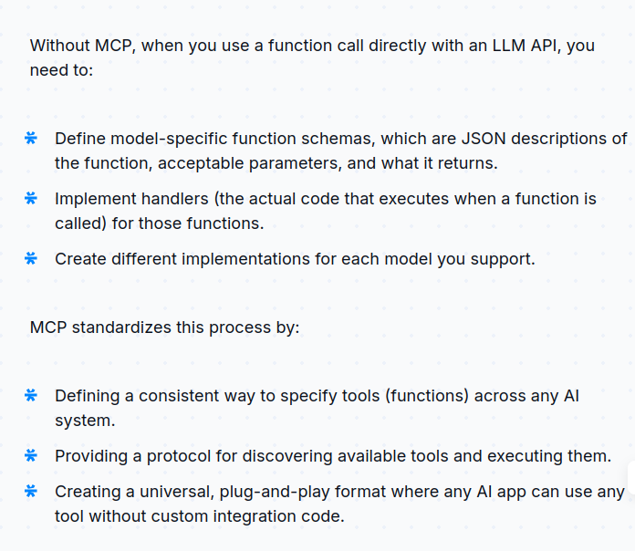

https://youtu.be/GQDHxlKJe_M?si=ucaZExXhrdzeIITu





